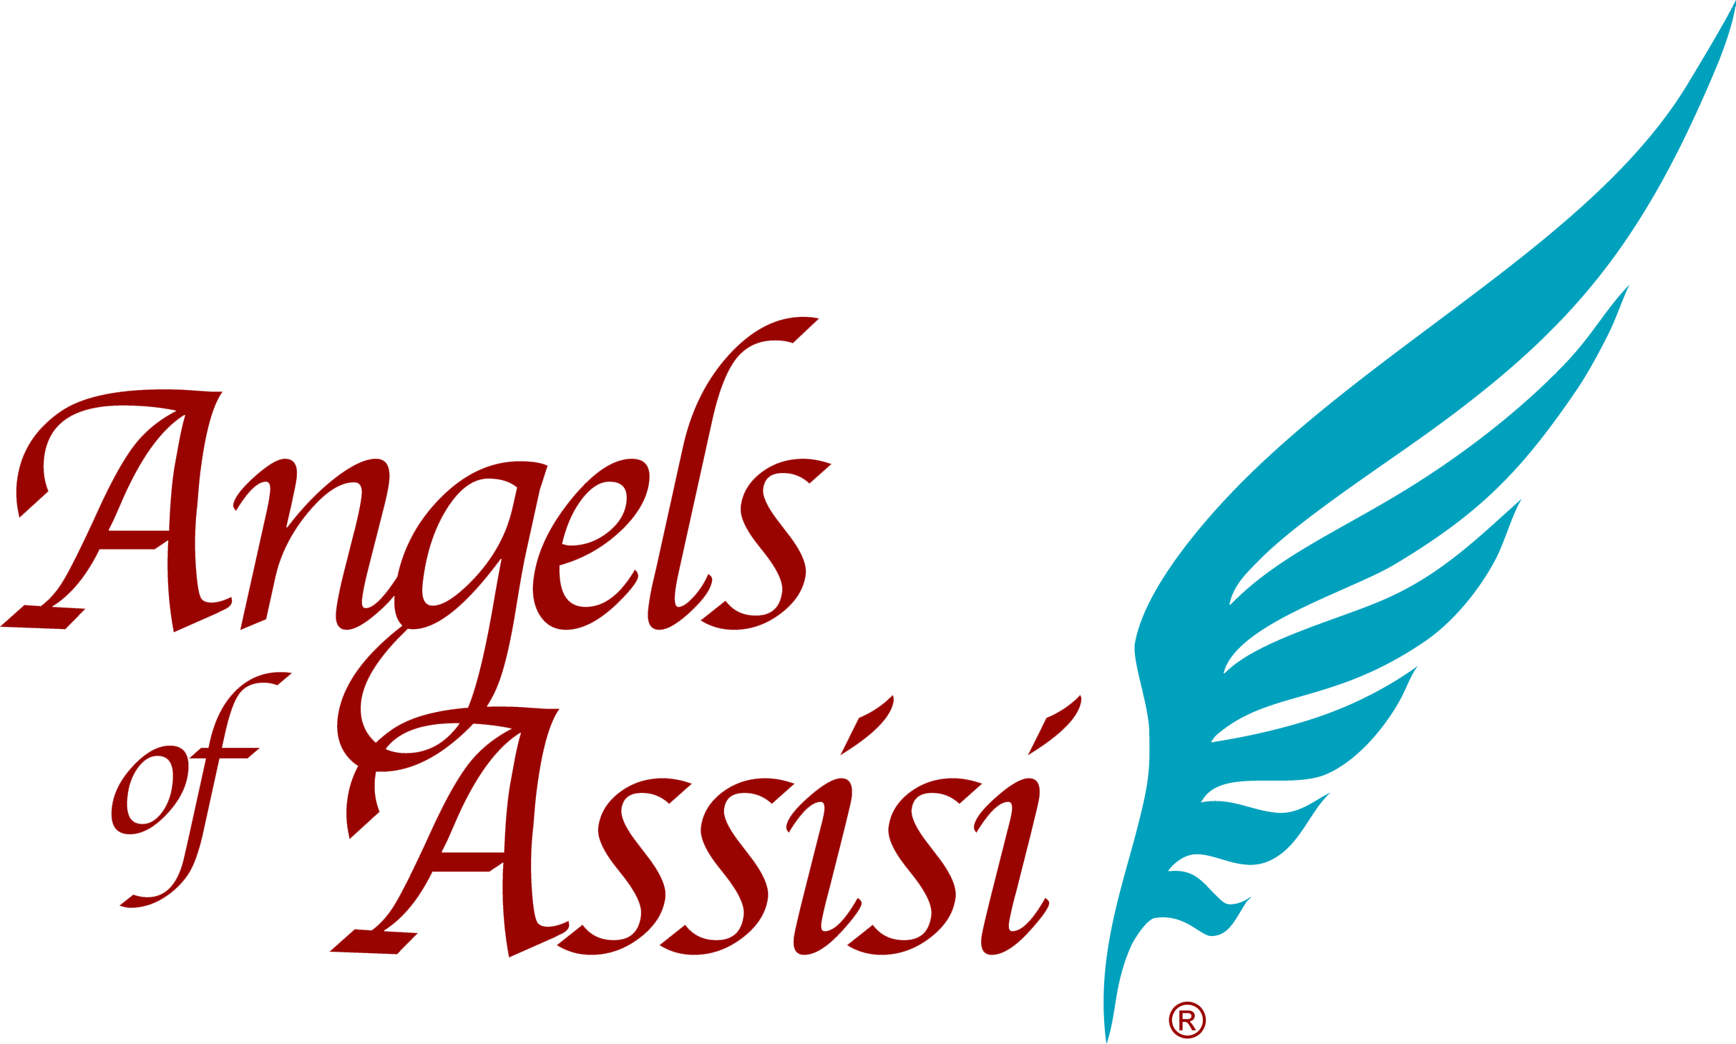
March 25, 2014
FOR IMMEDIATE RELEASE
Contact: Lisa O’Neill
540-400-2233
loneill@angelsofassisi.org
ANGELS OF ASSISI AWARDED MENTORSHIP FROM THE HUMANE SOCIETY OF THE UNITED STATES
Grant and Training Designed to Help Implement Community Outreach Program in Roanoke
ROANOKE, VA — MARCH 25, 2014 Angels of Assisi has received a $25,000 grant from the Elinor Patterson Baker Foundation to bring resources and services to underserved pet owners in Roanoke.
The program, named Pets for Life, aims to build more humane communities and create lasting and sustainable change in neighborhoods across the United States
Angels of Assisi is the only organization in Virginia to qualify for the mentorship, and is one of 22 cities nationwide to take part in the program established by the Humane Society of the United States in 2011.
Executive Director, Lisa O’Neill, says that the program will give residents in underserved communities easy access to pet services, including spay/neuter, wellness, dog training, and information that will pave the way to positive, long-term change for the animals, families, and the community.
“We believe strongly in the bond between animals and people, and trust that improving the lives of the pets in underserved neighborhoods will also enhance the lives of the people who care for them,” O’Neill said in a statement.
Please visit http://angelsofassisi.org/programs/pets-life/ for additional information.
_____________________________________________________________________________________
Angels of Assisi is a 501 (c) (3) non-profit organization dedicated to the preservation and care of all living creatures. We provide reduced cost medical care to companion animals with special emphasis on spaying and neutering to prevent pet overpopulation. We provide shelter, care and sustenance to companion and domesticated farm animals in need, including an adoption center for homeless dogs and cats and a farm animal sanctuary.

